Press Release
October 2025
Human Resource Accreditation Institute (HRAI)
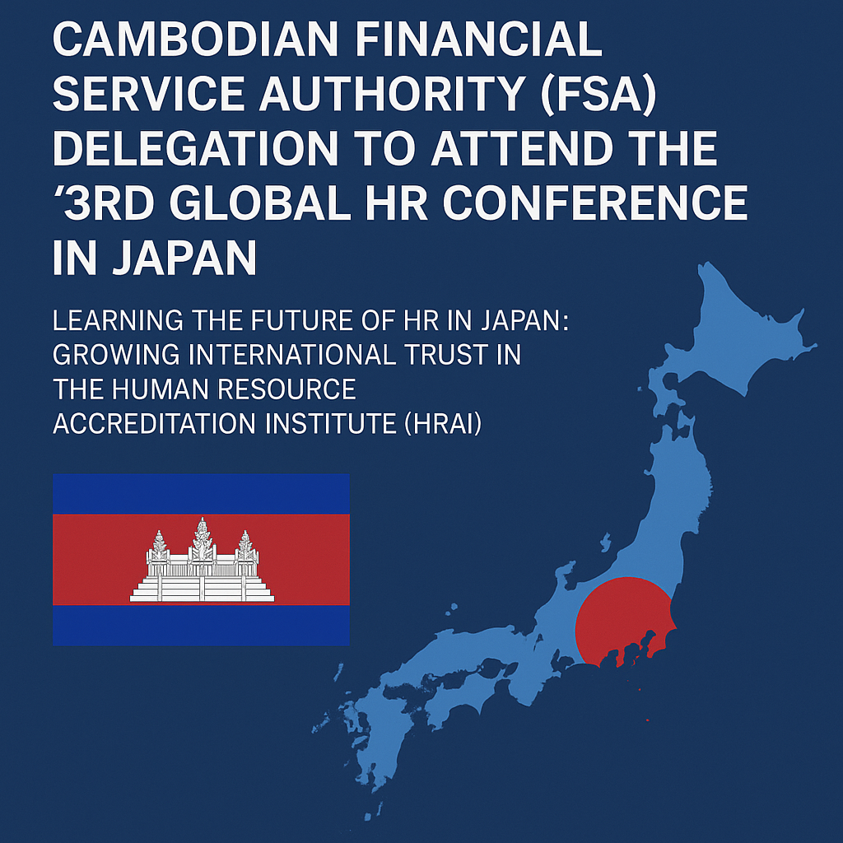

Delegation from the Financial Service Authority (FSA) of Cambodia to Attend the 3rd Global HR Conference in Japan —
HR Connecting Japan to the World through the Future of Human Capital Management
The Human Resource Accreditation Institute (HRAI), chaired by Fumie Hanazono, officially received a delegation request from the Financial Service Authority (FSA) of Cambodia on September 28, 2025.
As a result, six selected officers from the FSA of Cambodia will officially participate in the 3rd Global HR Conference (25GHR Tokyo) to be held in Tokyo this November.
This represents a landmark moment in Asia’s growing collaboration on human capital management — with Cambodia recognizing Japan as a trusted model for strategic HR innovation and learning.

Prime Minister Hun Manet stated that “Cambodia needs more qualified human resources,” positioning education reform and talent development as national priorities.
(Source: Khmer Times).
This delegation reflects the Cambodian government’s apparent intent to learn directly from Japan’s experience and apply its insights toward the country’s next stage of growth.

Why Japan Was Chosen?
Global Focus on Human Capital Management and HR Innovation
Japan is at a defining turning point in the evolution of HR.
Driven by demographic change, workplace transformation, and globalization, the nation is accelerating reforms in human capital management, people analytics, and DE&I (Diversity, Equity & Inclusion).
Traditional frameworks of lifetime employment and seniority are being replaced by job-based and skill-based systems, designed to maximize individual capability and organizational agility.
Despite the challenges of the “Lost Three Decades,” Japan remains an advanced economy, demonstrating resilience and reinvention.
Its ability to maintain human-centric (people-first) values while integrating data-driven, AI-enabled decision-making has drawn strong global attention.
As organizations begin to implement People Analytics and AI in HR, Japan is poised to offer a new model of balanced innovation — one that blends empathy with evidence and human wisdom with technology.
This balance between human-centricity and data-driven insight defines Japan’s distinctive contribution to the future of global HR.

HRAI — Japan’s Hub for Global HR Education and Collaboration
The Human Resource Accreditation Institute (HRAI) serves as a trusted bridge between Japan and the world through its international HR certification programs and partnerships with governments, HR associations, and academic institutions worldwide.
HRAI offers the globally recognized GHR-Professional™ certification, cultivating HR professionals who can align people strategy with business strategy on a global scale.
In May 2024, HRAI hosted 14 HR officers from the Bangkok Metropolitan Administration (BMA) for a one-week Global HR Education Program in Tokyo. Participants learned Japan’s practical approaches to human capital management and exchanged policy insights for application in their own countries.
At the 2nd Global HR Conference (24GHR Tokyo) in November 2024, HRAI welcomed a delegation of eight officers from the Korean National Police Agency, deepening mutual understanding of HR leadership, data governance, and public-sector transformation.
Through such initiatives, HRAI has become Japan’s hub for global HR collaboration, where education, innovation, and policy dialogue converge.

HR Connecting Japan to the World ~The Vision of the 3rd Global HR Conference (25GHR Tokyo), a message from Fumie Hanazono, Founder &Chair, Human Resource Accreditation Institute (HRAI)
Across nations and cultures, the essence of HR remains universal: to value people, empower growth, and co-create a sustainable future.
The 3rd Global HR Conference (25GHR Tokyo) is not merely an international gathering; it is a platform for learning and friendship in human capital management, where HR connects Japan to the world through shared knowledge and collective purpose.
Delegations from the United States, the Philippines, Malaysia, Singapore, India, Brunei, the United Arab Emirates, South Korea, Australia, and Ghana, among others, have joined previous editions. Each delegation came with a strong desire to learn from Japan’s approach to human capital management and to strengthen global friendship.
As these international collaborations expand, HRAI hopes to see more participants from Japan engaging as active contributors and thought leaders—sharing Japan’s insights, values, and innovations with the world.
“Japan is now creating a new model for social and economic growth by merging human capital management with AI and data analytics.
To shape the future of HR, it is essential to share knowledge and cultivate expertise across organizational and national boundaries.
The participation of leaders from Cambodia and other nations marks a significant step toward building the future of international HR.”

Event Overview — The 3rd Global HR Conference (25GHR Tokyo)
Theme: “The Future of HR — Collaboration with AI and Diversity from the Perspective of Japan and the World”
Languages: Japanese and English
Dates: November 11 (Tue) – 13 (Thu), 2025
Day 1: Keynote Session & Banquet
- Keynote: 13:00–17:00
- Banquet: 18:30–20:30
- Venue: Vision Center Tokyo Toranomon
T-LITE Building 4F, 2-4-7 Toranomon, Minato-ku, Tokyo
Access
Days 2–3: Workshop Sessions
- Dates: November 12–13, 2025 (Wed–Thu)
- Time: 13:00–18:00
- Venue: House of Representatives First Members’ Office Building (International Conference Room)
2-2-1 Nagatacho, Chiyoda-ku, Tokyo
Organizer: Human Resource Accreditation Institute (HRAI)
Official Website: https://www.ghrjapan.org

Media & Press Inquiries
Media invitations and press passes are available for journalists and organizations interested in covering the 3rd Global HR Conference (25GHR Tokyo).
For interviews, press coordination, or on-site coverage arrangements, please contact:
📩 Email: info@hr-ai.org
(Attn: HRAI GHR office)

Contact Information
Human Resource Accreditation Institute (HRAI)
E-mail: info@hr-ai.org
Website: https://www.hr-ai.org

Global HR Education Program (GHR-P) and Global HR Certification (GHR-Professional™)
🔗 https://www.ghrjapan.org/ghrp
The Human Resource Accreditation Institute (HRAI) offers the Global HR Education Program (GHR-P) as a new standard for global HR education originating from Japan.
This program offers a structured curriculum that covers the latest global HR knowledge, equipping learners with practical and worldly applicable professional skills.
Upon completing the program, participants become eligible to earn the Global HR Certification (GHR-Professional™). This certification demonstrates advanced expertise in global HR practices and serves as a foundation for ongoing professional development and continuous upskilling.
Certified professionals also gain access to GHR-CONNECTION, HRAI’s membership platform that enables ongoing learning and global networking opportunities.
Through HR education and certification, HRAI contributes to the development of HR professionals in Japan and worldwide, empowering them to drive organizational and human capital advancement on a global stage.

Other GHR Global HR Programs

People Analytics Foundation Program
Certification: GHR-PATM
🔗 https://www.ghrjapan.org/peopleanalytics

Global HR Business Partner Program
Certification: GHR-BPTM
🔗 https://www.ghrjapan.org/hrbp

GHR Basic Program (Introductory Course)
Certification: GHR-BasicTM
🔗 https://www.ghrjapan.org/ghrbasic

CHRO Academy
Certification: GHR-CHROTM
(Launching in 2026)
A complete overview of all program levels is available here:
🔗 https://hr-ai.org/

Global HR Networking Platform
GHR-CONNECTION
A members-only platform for continuous learning, dialogue, and collaboration among certified global HR professionals.
🔗 https://www.ghrjapan.org/ghrc

