広報画像キャプション

1 | 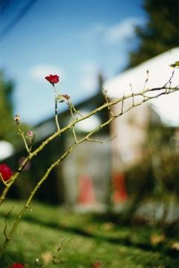 | Terri Weifenbach “Between Maple & Chestnut, BMC 53” 2006  ©︎Terri Weifenbach, Courtesy Blitz Gallery
2 | 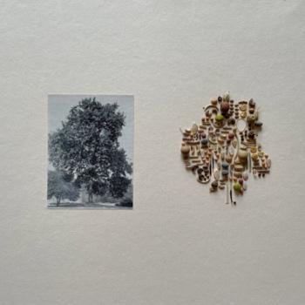 | 竹之内祐幸「距離と深さ」より 2018年 ※参考作品  Hiroyuki Takenouchi “Distance and Depth” 2018 *referential work  ©︎Hiroyuki Takenouchi, Courtesy PGI
3 | 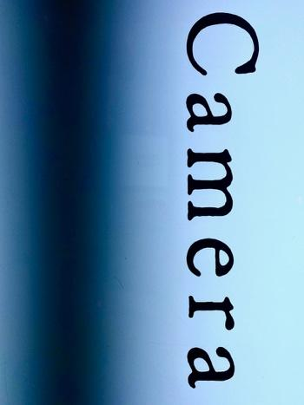 | 安瀬英雄《Stripe(50Hz) 2022/03/03 20:37:39 shinjuku-ku》2022  Hideo Anze “Stripe(50Hz) 2022/03/03 20:37:39 shinjuku-ku” 2022  ©Hideo Anze, Courtesy KANA KAWANISHI GALLERY
4 | 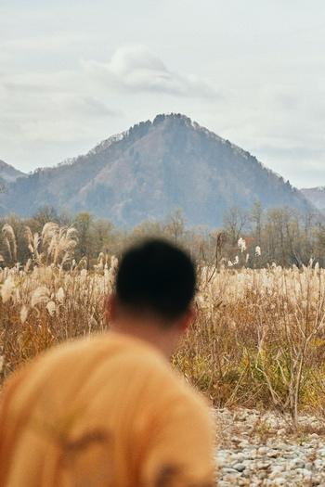 | 野村浩 《Slash》2014年  Hiroshi Nomura “Slash” 2014  ©︎Hiroshi Nomura, Courtesy POETIC SCAPE
5 | 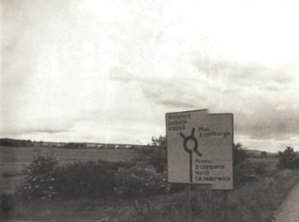 | 山沢栄子《What I am doing No.09》1980年  YAMAZAWA Eiko “What I am doing No.09” 1980  ©︎YAMAZAWA Eiko, Courtesy The Third Gallery Aya
6 | 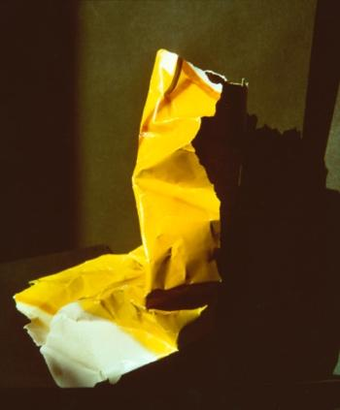 | 上野王香《non GMO #01》2022年  Ouka Ueno “non GMO #01” 2022  ©︎Ouka Ueno, Courtesy BLOOM GALLERY
7 | 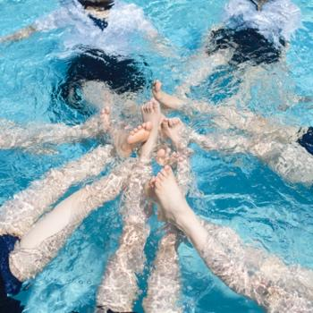 | 青山裕企《Schoolgirl Complex A to Z 312》2018年  写真提供：青山裕企（出品：和田画廊）  Yuki Aoyama “Schoolgirl Complex A to Z 312” 2018  Photo by Yuki Aoyama (Presentation by WADA GAROU TOKYO)

